**Experiment no – 01 (D)**

**Aim:** Write a function that reverses the user defined value.

**Theory: -**

**Practical Implementation**:-

**Code**:-

num = 1234

reversed_num = 0

while num != 0:

digit = num % 10

reversed_num = reversed_num * 10 + digit

num //= 10

print("Reversed Number: " + str(reversed_num))

**Output:**

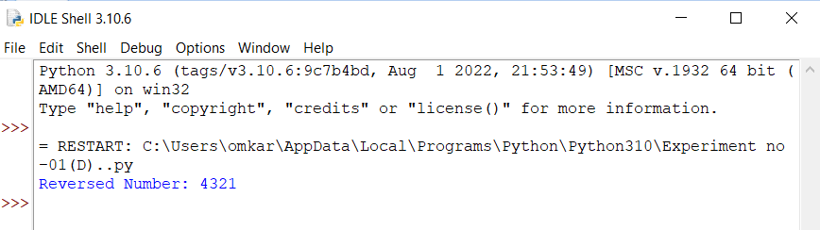

**Conclusion :** This is program successfully run.